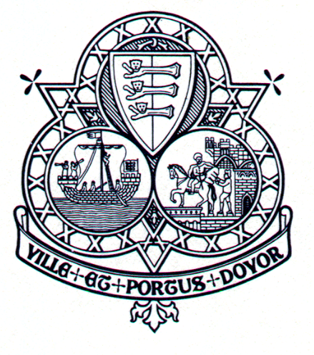

DOVER TOWN COUNCIL

MEETING ROOM HIRE CHARGES

ROOM | Half Day: Mon- Fri  Morning:  9.30-13.00  Afternoon:  13.00-16.30 | Full Day: Mon-Fri  9.30-16.30
Council Chamber  - Seats up to 80 Theatre style  - Disabled access via lift  - Ante-chamber available including tea and coffee facilities | £75.00 | £120.00

A DISCRETIONARY DISCOUNT OF 50% IS OFFERED TO:

- PUBLIC SECTOR ORGANISATIONS
- DOVER RESIDENTS

DOVER BASED CHARITIES AND NON-PROFIT MAKING ORGANISATIONS MAY APPLY TO USE THE MEETING ROOMS FREE OF CHARGE

FOR FURTHER DETAILS AND FOR AVAILABILITY AND HIRE CHARGES OUTSIDE OFFICE HOURS PLEASE SEND AN E-MAIL TO bookings@dovertowncouncil.gov.uk OR CALL 01304 242625

