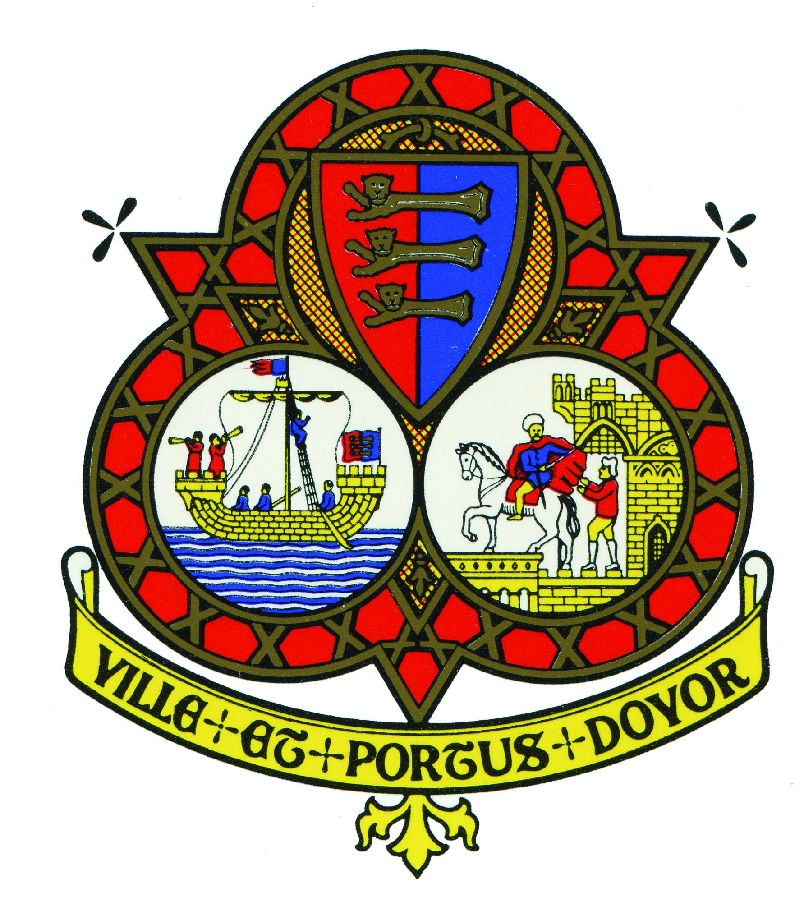

NOTICE OF COMMITTEE MEETING CANCELLATION

THE PLANNING COMMITTEE MEETING SCHEDULED FOR
4TH JULY 2022 HAS BEEN CANCELLED

THANK YOU

