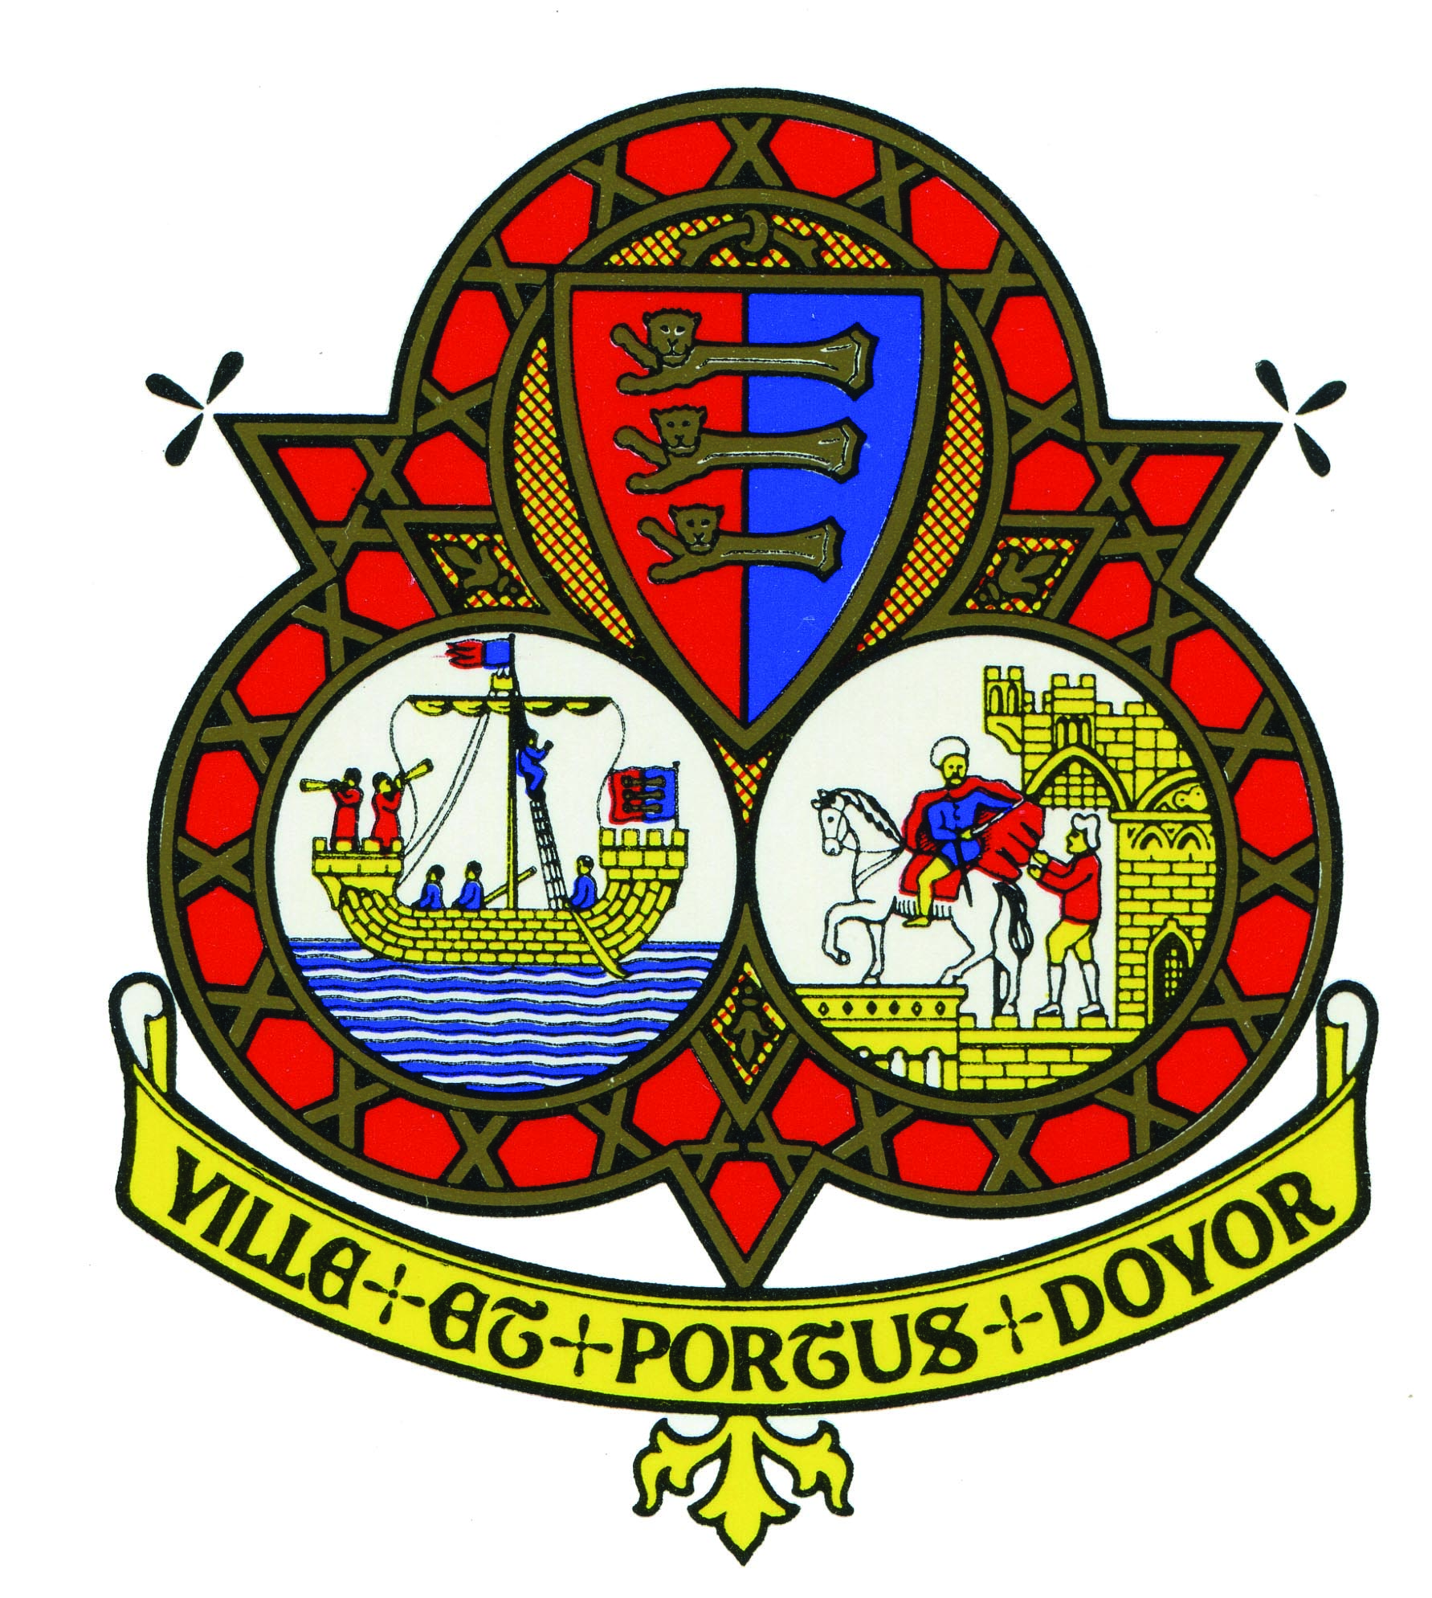

HONORARY FREEMAN NOMINATION FORM

If you have any difficulties or questions in filling in this form, please contact the Town Clerk on 01304 242625 or email council@dovertowncouncil.gov.uk

NOMINEE

Please clearly print or type the following details about the person you are nominating. You must ensure that all sections of this form are completed or we will be unable to consider your nominee.

Surname:……………………………………………………………………………………………….

Forenames:…………………………………………………….. Title:……………………………....

Address:……………………………………………………………………………………………..…

……………………………………………………………………………………………………...….

…………………………………………………………………………………………………………

Telephone No:…………………………………….. Mobile:…………………………………………

Email:………………………………………………………………………………………………….

THE RECOMMENDATION
In this section please set out details of how the nominee is connected to Dover and the significant contribution made by them in their area of activity whether it is in the public, private or voluntary sector. Please list all the roles and organisations to which the nominee has contributed, sections of the community which have benefitted, the length of service given and describe what makes this person worthy of this honour and recognition. It is important that you give as much detail as possible about what your nominee has achieved.

…………………………………………………………………………………………………………

…………………………………………………………………………………………………………

…………………………………………………………………………………………………………

…………………………………………………………………………………………………………

…………………………………………………………………………………………………………

…………………………………………………………………………………………………………

…………………………………………………………………………………………………………

…………………………………………………………………………………………………………

…………………………………………………………………………………………………………

…………………………………………………………………………………………………………

…………………………………………………………………………………………………………

…………………………………………………………………………………………………………

…………………………………………………………………………………………………………

…………………………………………………………………………………………………………

…………………………………………………………………………………………………………

…………………………………………………………………………………………………………

…………………………………………………………………………………………………………

…………………………………………………………………………………………………………

…………………………………………………………………………………………………………

………………………………………………………………………………………………………....

…………………………………………………………………………………………………………

…………………………………………………………………………………………………………

…………………………………………………………………………………………………………

…………………………………………………………………………………………………………

…………………………………………………………………………………………………………

…………………………………………………………………………………………………………

…………………………………………………………………………………………………………

…………………………………………………………………………………………………………

…………………………………………………………………………………………………………

…………………………………………………………………………………………………………
You may use additional sheets of paper, but please ensure that you state to which section the additional information you are providing relates. Please do not send in examples of the nominee’s work (e.g. videos, photographs, books) as we cannot take responsibility for their safekeeping.

DETAILS OF PERSONS MAKING THE NOMINATION
Please provide your details.

Surname:……………………………………………………………………………………………….

Forenames:…………………………………………………….. Title:……………………………....

Address:……………………………………………………………………………………………..…

……………………………………………………………………………………………………...….

…………………………………………………………………………………………………………

Telephone No:…………………………………….. Mobile:…………………………………………

Email:………………………………………………………………………………………………….

Relationship to nominee:……………………………………………………………………………....

Signature:………………………………………………………………………………………………

Date:……………………………………………….

Confidentiality: it is imperative that your submission is not discussed with any other person. Any disclosure will make this application invalid.

Please send this form with any enclosures (marked confidential) to:
The Mayor of Dover
Dover Town Council
Maison Dieu House
Biggin Street
Dover
Kent
CT16 1DW

