REMEMBRANCE DAY SERVICE AND PARADE
Dover War Memorial Sunday 14th November 2021
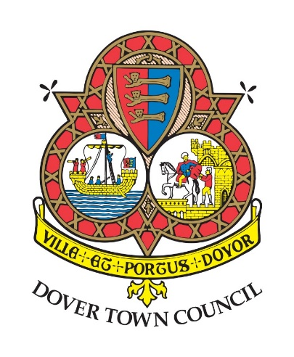

IN MEMORY OF THE PEOPLE OF DOVER WHO HAVE GIVEN THEIR LIVES IN THE SERVICE OF THEIR TOWN & COUNTRY

Officiated by: Reverend Catherine Tucker, Team Rector (Interim), Dover Town Team Ministry
Flt. Lt. Malcolm Sawyer RAFVR (Rtrd), Chaplain to the Royal British Legion (Dover)

10.55am BIDDING
REMEMBRANCE
The Ode (Exhortation)
The Last Post
11.00am THE SILENCE
The Reveille
The Kohima Epitaph
AN ACT OF COMMITMENT
Let us pledge ourselves anew to the service of God and humanity: That we may help, encourage and comfort others, and support those working for the relief of the needy and for the peace and welfare of all nations.

Lord God our Father, we pledge ourselves to serve you and all your peoples in the cause of peace, for the relief of want and suffering and for the praise of your name. Guide us by your Spirit; give us wisdom; give us courage; give us hope; and keep us faithful now and always for thy name’s sake. Amen.

HYMN
O God, our help in ages past, our hope for years to come,
Our shelter from the stormy blast, and our eternal home. Beneath the shadow of thy throne, thy saints have dwelt secure. Sufficient is thine arm alone, and our defence is sure.
Before the hills in order stood, or earth received her frame,
From everlasting thou art God, to endless years the same.
A thousand ages in Thy sight are like an evening gone,
Short as the watch that ends the night, before the rising sun.
Time, like an ever-rolling stream, bears all its sons away,
they fly, forgotten, as a dream dies at the opening day. O God our help in ages past, our hope for years to come, be thou our guard while troubles last, and our eternal home.

ADDRESS

PRAYERS

Our Father, who art in heaven, hallowed be thy name; thy kingdom come; thy will be done; on earth as it is in heaven. Give us this day our daily bread. And forgive us our trespasses, as we forgive those who trespass against us. And lead us not into temptation; but deliver us from evil. For thine is the kingdom, the power and the glory, for ever and ever. Amen.

HYMN
Eternal Father, strong to save, whose arm doth bind the restless wave, Who bid’st the mighty ocean deep Its own appointed limits keep; O hear us when we cry to thee For those in peril on the sea.

O Christ, the Universal Lord, Who suffered death by nails and sword, from all assault of deadly foe Sustain thy soldiers where they go; And evermore hold in thy hand All those in peril on the land.

O Holy Spirit, Lord of Grace, who fills with strength the human race, inspire us all to know the right; Guide all who dare the eagle’s flight; And underneath thy wings of care Guard all from peril in the air.
O Trinity of love and power! Our brethren shield in danger’s hour; From rock and tempest, fire and foe, protect them wheresoe’er they go; Thus, evermore shall rise to thee Praise from the air, the land and sea.

THE LAYING OF WREATHS
THE BLESSING

THE NATIONAL ANTHEM
God save our gracious Queen, long live our noble Queen, God save the Queen.
Send her victorious,
Happy and glorious,
long to reign over us:
God save the Queen.

PARADE MARCH PAST ST MARY’S CHURCH, CANNON STREET, WHERE THE TOWN MAYOR WILL TAKE THE SALUTE.

