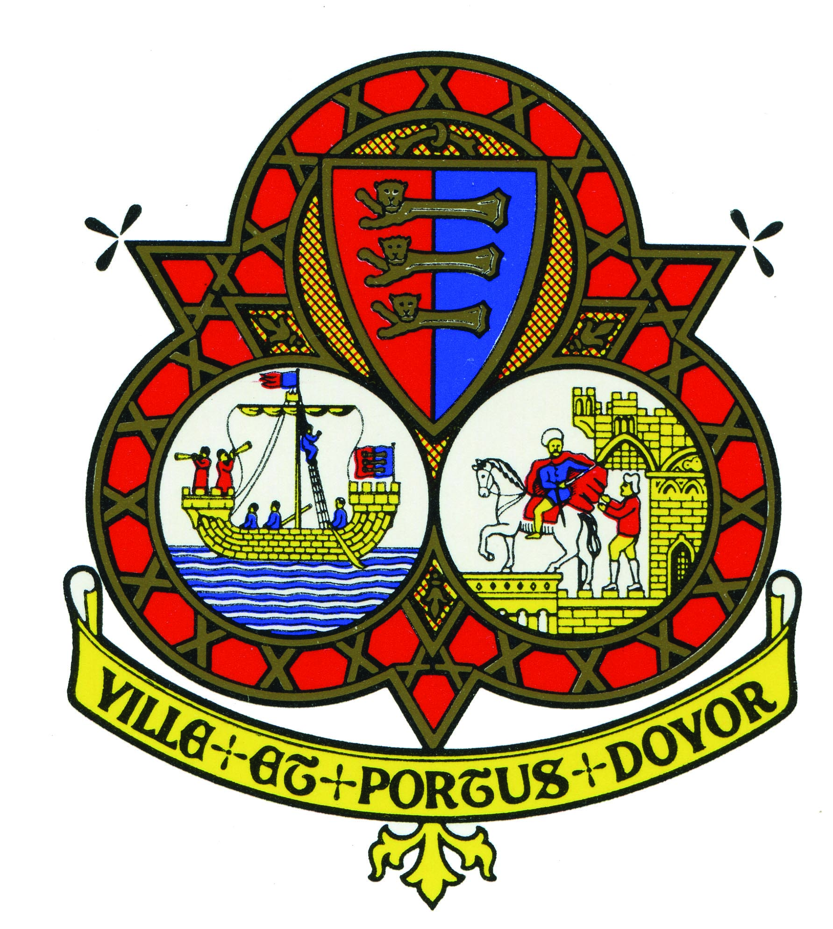
DOVER TOWN COUNCIL

Grant Application Form
for grants under £250
A: APPLICATION SUMMARY

Name of organisation:
Registered Charity No (if applicable): | Registered Company No (if applicable):

Please note: If your application is successful, cheques will be made payable to the ABOVE.

Address of organisation:

Telephone:

Name of contact:

Fax:

Email:

Address of contact (if different from above):

What do you intend to do with the grant?:

£
How much is requested from Dover Town Council?
£
Total project/event cost (if applicable):

Declaration:

I hereby declare that I have the authority to submit this application on behalf of the organisation detailed above and that all information provided is true and accurate to the best of my knowledge. I agree to complete and return any forms relating to this application which are sent to me in the future:

Signed: ………………………………………………………. Date: …………………………….......

Name (Block capitals): ………………………………………………………………………….……….

Status (e.g. Chairperson, Secretary): …………………………………………………………………

Please note: The information provided on this application will be held on a database and used to provide information to officers and members of the Town Council.
B: THE PROJECT / EVENT / ACTIVITY

Description and aims of project/event/activity (please explain how it will benefit the people of your ward or the Town of Dover):

When will the project/event or activity take place and when do you intend to spend the grant – if different?:

C: FINANCIAL DETAILS

£
Estimated total cost:

Please detail the components of your project/event i.e. your budget or costings (submit on a separate sheet if necessary):

Costs for the project/item/activity | £
TOTAL | £

Where is all the money needed coming from? | £
TOTAL | £

TOTAL INCOME LESS TOTAL EXPENDITURE |  | £

D: COUNCILLOR GRANT SCHEME

IF YOU ARE APPLYING FOR A GRANT UNDER THE COUNCILLOR GRANT SCHEME PLEASE COMPLETE THE FOLLOWING:

Councillor Grant Scheme: (To be filled in by the applicant)

If your grant application is being made under the Town Council’s “Councillor Grant Scheme” please tell us which Councillor/s is/are supporting your grant and which ward(s) this will benefit
Councillor: ________________________________ Ward: ______________________________

Signature of Councillor:

Councillor: ________________________________ Ward: ______________________________

Signature of Councillor:

Councillor: ________________________________ Ward: ______________________________

Signature of Councillor:

Councillor: ________________________________ Ward: ______________________________

Signature of Councillor:

Please return your completed form to:

Secretary to the Council
Dover Town Council
Maison Dieu House
Biggin Street
DOVER
Kent CT16 1DW

Tel: (01304) 242625
Fax: (01304) 241445
Email: council@dovertowncouncil.gov.uk

Please note that an application may be submitted by email but must be signed by councillor(s) before it can be processed.

DOVER TOWN COUNCIL’S FINANCIAL ASSISTANCE FEEDBACK

Send to: The Town Clerk  Dover Town Council  Maison Dieu House  Biggin Street  DOVER  Kent CT16 1DW  Email: council@dovertowncouncil.gov.uk | TO BE RETURNED WITHIN 2 MONTHS OF THE PROJECT OR EVENT BEING COMPLETED  THANK YOU

Each Dover Town Council grant is paid with local government funds and, by law, the Town Council is required to account for how its money is spent and what value any grant has provided to the town. As the recipient of public sector funding, you are required to provide the information listed below. We may ask you for more details and if you are not able to demonstrate that the grant has been spent as agreed when the funding was authorised, then you may be asked to repay it. Please be aware that in line with legislation, the details of all grants and expenditure are published online – this includes the details of the organisation and the agreed purposes of the spend.

If there is insufficient space, please continue on blank sheets of paper.

Name of Organisation:
Grant amount awarded:
How have the funds been used? This must agree with the budget you provided in your application – please use it for reference here, providing dates for spend, costs, payees and other details as appropriate.

Please attach evidence for all items of expenditure – this can include receipts, paid invoices, copies of issued cheques etc.

As part of the funding agreement, you are required to acknowledge publicly the contribution from DTC. The details of how this would be done should be in your funding agreement. Please list here the forms in which acknowledgement took place and confirm this happened. Examples might be the placing of a plaque or sticker at the location of the grant expenditure, the authorised use of the DTC crest on any marketing material and the inclusion of the contribution in any publicity or press material in any form including electronic.

How did the grant benefit the people of Dover? Again – you should refer to your application and provide details of participants or beneficiaries exactly as you included in your application. Please indicate where there are any differences from your forecast and tell us why you think the real effects were different to those intended.

Please include photographs or videos or any other material which show the grant delivering value to Dover.
Signature of at least one applicant named on the grant application form:

Date:
Print Name / Position in organisation

