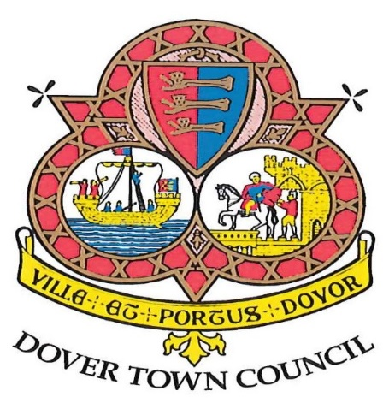

NOTICE OF CANCELLATION
FOR
COMMITTEE MEETINGS

Civic & Special Projects Committee Meeting scheduled for
4th June 2020
--------------
Planning Committee Meeting scheduled for
8th June 2020

THANK YOU

