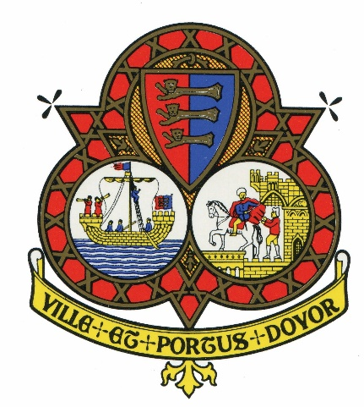

NOTICE OF CANCELLATION
FOR COMMITTEE MEETING

Finance & General Purposes Committee

The meeting of the Committee scheduled for 4th DECEMBER 2019, has now been cancelled.

THANK YOU

